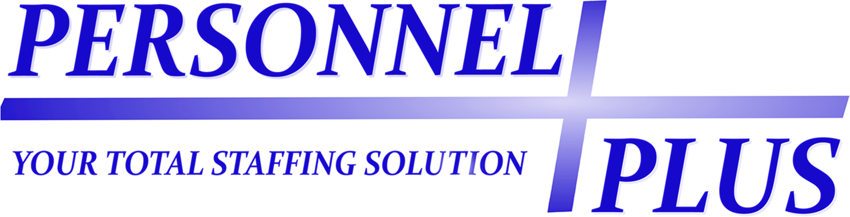
SAFETY POLICY STATEMENT
Personnel Plus is dedicated to ensuring a safe workplace environment for all of our employees. Our goal is to have zero on-the-job injuries. As an employee of Personnel Plus, it is essential that you are aware of and understand this goal, as well as all other Personnel Plus and jobsite safety requirements. We are committed to your safety and well-being, and you must also take personal responsibility for always conducting yourself in a safe and responsible manner. You should always think “safety first” before initiating any task. We expect you to always perform your duties in a manner that is consistent with this “zero injuries” goal. We ask that you read and understand the following safety policy. You are responsible for seeking clarification with us if any part of this policy is unclear. As an employee with our company, you will be required to acknowledge this policy and conform to its requirements.
EMPLOYEE SAFE WORK PROCEDURES
Personnel Plus strives to ensure a safe workplace for all employees and has established a goal of zero on-the-job injuries. As such, you must adhere to all workplace safety requirements. Following are general safety guidelines that you will be expected to follow:
- You should never perform a task that you believe to be unsafe, or that is beyond your physical capability. Always ask for help if needed.
- You will be required to comply with all safety policies and procedures in place at your jobsite. If any jobsite policy or procedure is unclear to you, it is your responsibility to seek clarification from your jobsite supervisor.
- Appropriate PPE (personal protective equipment) will be issued to you as needed for your assignment. You are required to use PPE correctly and at all times necessary for the task being performed.
- You may operate vehicles, equipment, or tools only if specifically authorized and trained to do so. Safety guards and devices must always be operable and in place while equipment is in use. Never use equipment, tools, or vehicles that are not in safe operating condition.
- If at any time you are asked to perform work in an unsafe manner, you are required to:
  - STOP and inform your jobsite supervisor of your safety concern
  - if asked to continue, you should request a modification to ensure safe work conditions
  - if no modification is made, you should request alternative work that you can safely perform
  - if no alternative work is available, you should immediately request to contact your Personnel Plus supervisor to discuss your safety concern
  - if no resolution is determined, you may leave your work area only after receiving authorization from your Personnel Plus or jobsite supervisor
- If you witness or experience a “near-miss incident,” you must report it immediately to your jobsite and Personnel Plus supervisors so that any existing hazard can be eliminated.
- You may always contact your Personnel Plus office if you have any question or concern related to the safety of your jobsite.
INJURY OR ILLNESS REPORTING – RETURN-TO-WORK POLICIES
- If you are injured in any jobsite incident, or have incurred a work-related illness at a jobsite, you must:
  - Immediately report the incident to your direct jobsite supervisor (not a co-worker).
  - Report the incident to your Personnel Plus office no later than the end of your shift that day. Go to: http://www.personnelplus-inc.com/include/content/contact.asp for Personnel Plus office contact information. In any non-emergency situation, you must contact Personnel Plus before seeking medical treatment. You can reach a representative at any time outside business hours by calling the local Personnel Plus on-call phone number.
  - Anyone experiencing a medical emergency should be immediately transported to and treated at the nearest hospital emergency room.
  - You are required to complete an incident report with the Personnel Plus office, and may be required to submit to a post-accident drug test.
- Any safety incident or injury that is reported after the end of your scheduled shift on the day of occurrence may be deemed a violation of this policy and could result in your claim being denied. Personnel Plus reserves the right to investigate any claim of injury.
- If you require medical care, you must be treated by a Personnel Plus-designated medical provider. You are required to view the designated medical providers for your area [available here: http://www.personnelplus-inc.com/include/content/medproviders/]. If you seek treatment from any unapproved provider, you may be responsible for payment of any unauthorized treatment costs.
- If you have sought treatment from a designated provider, you should be given a form indicating your return-to-work status. You are required to provide that form to the Personnel Plus office immediately following your treatment. If your designated provider has deemed that you are unable to return to your regular work duties, you will be offered modified work if available. You should remain in contact with your Personnel Plus office on a weekly basis until released to full duty by your treating physician.
- You must inform Personnel Plus in advance of all medical appointments. You are required to keep all appointments as scheduled. If you must reschedule any appointment, it must be approved in advance by Personnel Plus, unless the reschedule is a result of a medical emergency. Personnel Plus reserves the right to attend any medical visit.
I have read and understand the above policy and agree that I have viewed the list of designated medical providers for my area. I acknowledge that any failure to comply with this policy or with any client company jobsite safety requirement may be deemed a violation of this policy and may result in disciplinary action up to and including termination and can also result in the denial of worker’s compensation benefits. I understand that by my compliance with safety policies and procedures and my effort to always work in a safe manner, I can help ensure my own well-being and my success at any client company jobsite and with Personnel Plus.

